ECE 100 - Linear Electronics Systems

Lab Report 4 - Differentiator Circuit

November 18, 2022

Venz Burgos: A16230301

Professor: Saharnaz Baghadadchi

Table of Contents

Title: pg. 1

Table of Contents: pg. 2

Abstract: pg.3

Experimental Procedures: pg. 4

Results: pg. 5

Conclusion: pg. 15

MatLab Code: pg. 16

Abstract

The purpose of the lab is to explore the functions of the differentiator circuit and to explore the optimization of this circuit. In this lab, we will test this circuit with and without any compensation to find how the compensation will affect the overshoot and rise time of this circuit. Furthermore, we will also explore how altering the compensation will affect the damping coefficient and the natural frequency in the transfer function. Our goal for this circuit is to meet the spec by optimizing the compensation, resistor or capacitor, to get a certain overshoot and rise time.

Experimental Procedures

Problem 1: System Level Design

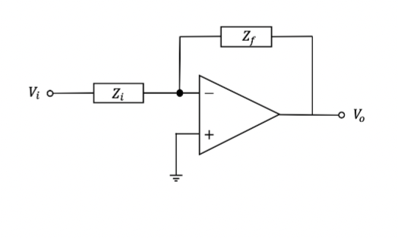

This figure above shows the circuit of the op-amp differentiator.

In the first part of the lab, we are tasked with designing a circuit that would convert a triangle wave into a square wave. We tested by building a circuit design that is ideal and calculated values of capacitors and resistors by hand. The issue with the circuit design is that it may be unstable so compensation resistors and capacitors needed to be added. You calculated the values for these using the general transfer function and the transfer function you derive from the circuit above.

Problem 2: Circuit Level Spice Simulation

In the next part of the lab, you use LTSpice or pSpice to simulate the circuit. You simulate the circuit without any compensation first. You might find that the circuit graph is unstable and causes a lot of oscillation. The next part you have to find a compensation resistor and compensation capacitor to see the effects on the graph. It should be more stable. You use the compensation values that you calculated in the first part of the experiment.

Problem 3: Measurement

In the last part of the lab you have to build the circuit you simulated in the second task. Simulating three circuits which are the circuit without compensation and the other two with the resistor and capacitor. You then measure the overshoot of each circuit as well as the rise time which should be given in the oscilloscope.

Results

Problem 1: System Level Design



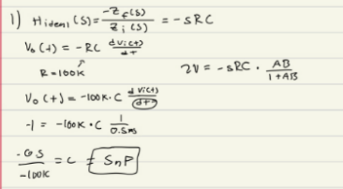

This figure above is the calculations for finding the capacitor value for Zi. We found the capacitance to be 5nF for a resistor value of 100k for Zf and dt being 0.5ms.

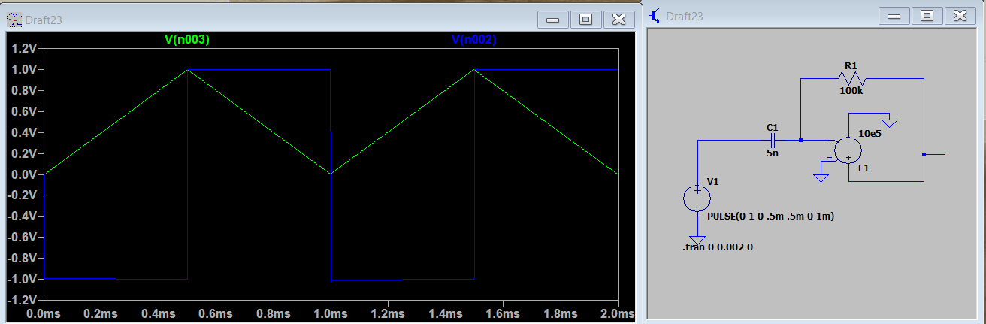

This figure above shows the simulation results of the differentiator circuit with the calculated capacitor value.



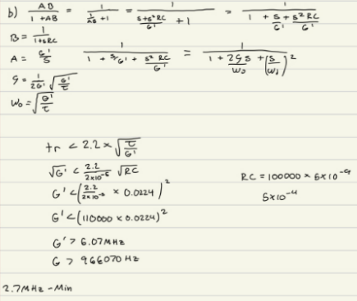

The figure above shows the calculations to find the minimum unity gain bandwidth needed for the differentiator circuit. We also found the natural frequency and the damping coefficient in terms of the unity gain and the time constant which is equal to R\*C. We found that the calculated value of the minimum unity gain bandwidth is satisfactory to the unity gain of the op-amp in the datasheet, G>2.7MHz.



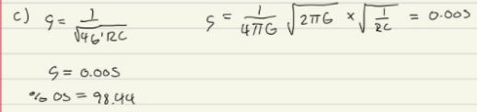

The figure shows the calculations to get the damping coefficient for this circuit with the minimum unity gain bandwidth of 2.7MHz. We plug in this calculated damping coefficient into the equation of the overshoot percentage, %os=100\*exp(. We found our overshoot percentage to be about 98.5%

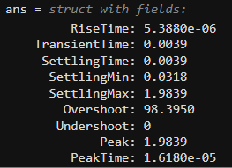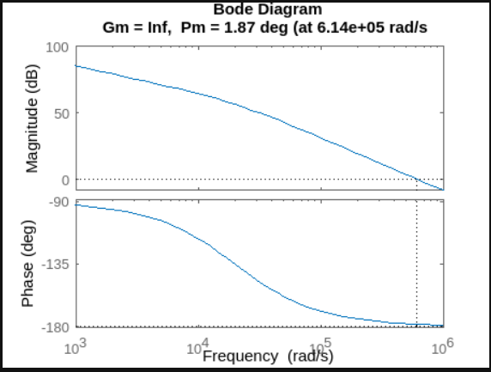

The figures above shows the Matlab simulation to find the simulated overshoot percentage and the phase margin and the frequency where the phase margin occurs (unity gain frequency) of the differentiator circuit without compensation. We found that the phase margin is 1.87 degrees occurring at 6.14\*10^5 rad/s.



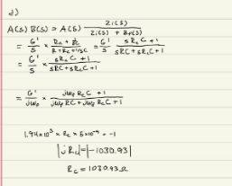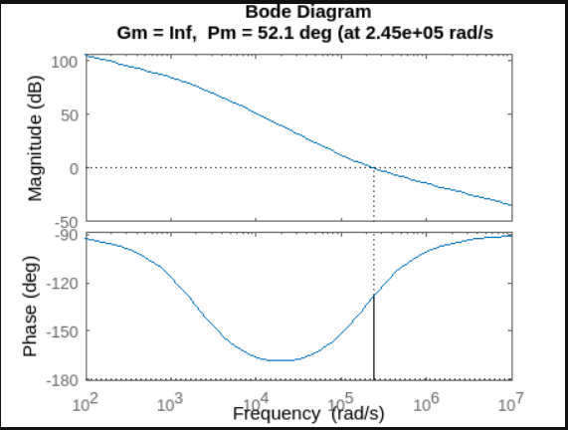

These figures above show the calculations of the compensation resistor and the Matlab simulation with this calculated resistor value. We found the compensation resistance to be 1030.93 Ohms to meet the spec of the differentiator circuit. We found our phase margin to be 52.1 degrees occurring at 2.45\*10^5 rad/s.

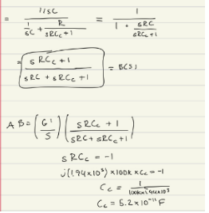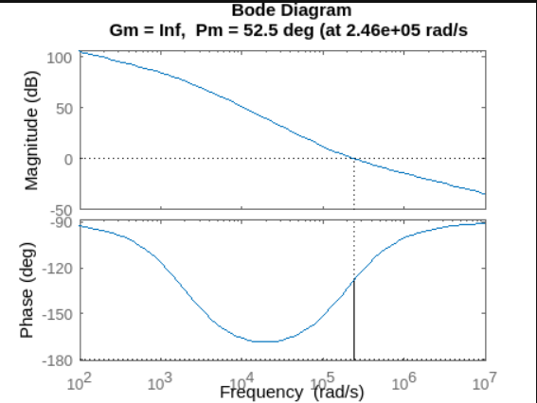

These figures above show the calculations of the compensation capacitor and the Matlab simulation with this calculated capacitor value. We found the compensation capacitance to be 52pF to meet the spec of the differentiator circuit. We found our phase margin to be 52.5 degrees occurring at 2.46\*10^5 rad/s. This shows that putting a capacitor in parallel with the resistor will result in the same spec as when we put a resistor in series with the capacitor of the circuit.

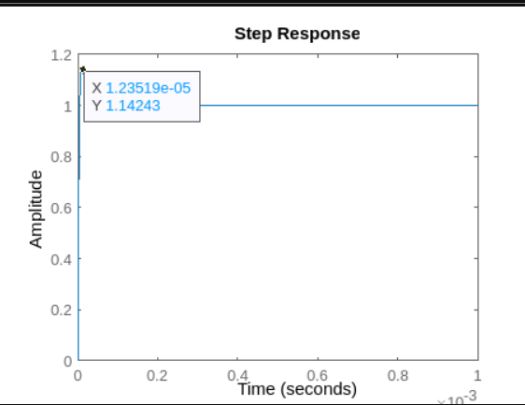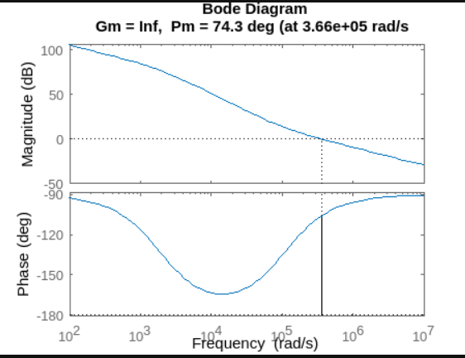

The figures above shows the step response when we adjust the compensation resistor value to meet the spec of the circuit and its bode plots to get its phase margin. To get an overshoot percentage of less than 15%, where the peak voltage would be less than 0.15V, then the compensation resistor should evaluate to at least 1900 Ohms. This will result of giving us a phase margin of 74.3 degrees occurring at 3.66\*10^5 rad/s.

Problem 2: Circuit Level Spice Simulation

1. 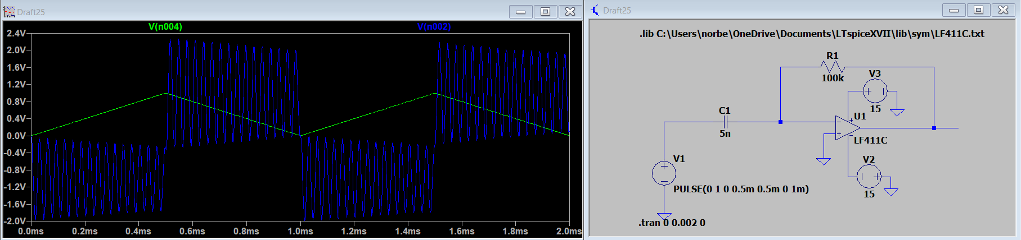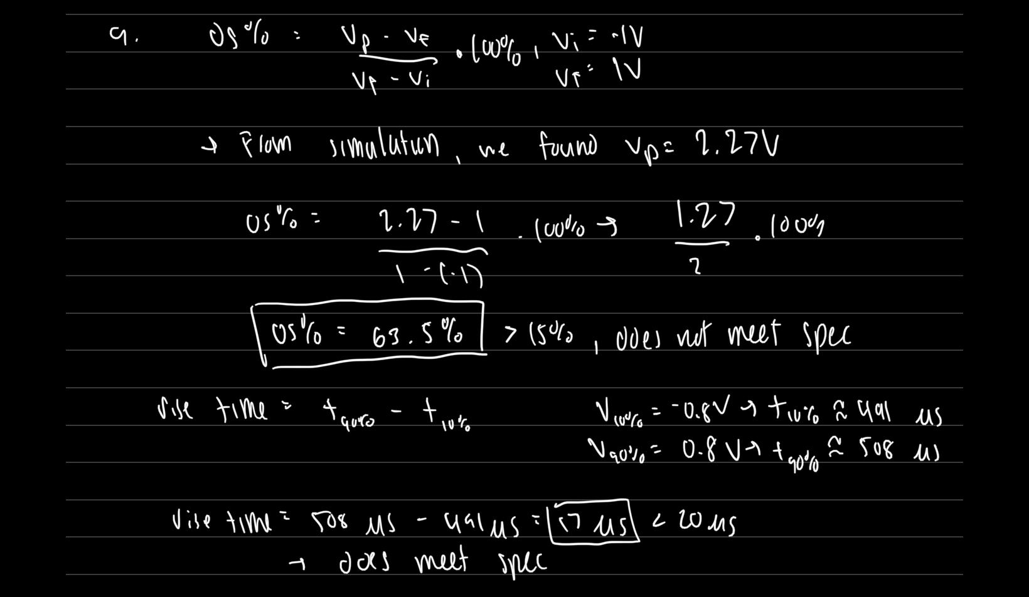

The circuit above shows the simulation results for the differentiator circuit without compensation. From measuring the plot of the output voltage, we found that the overshoot percentage is about 63% and the rise time is about 17 microseconds. Since the overshoot percentage without compensation is above the required maximum, this circuit does not meet the spec.

1. 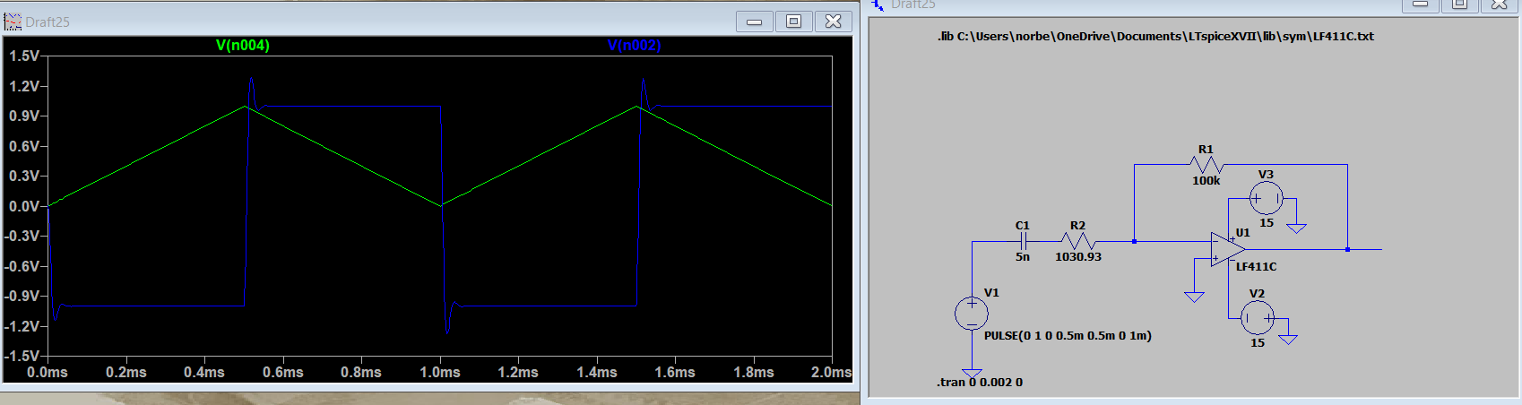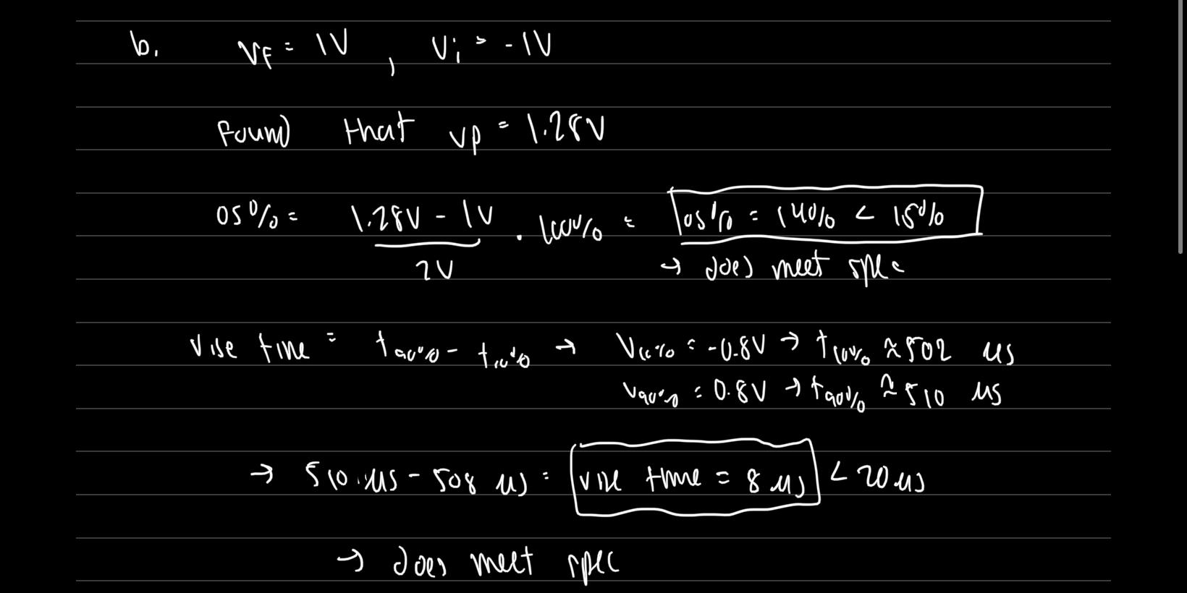

The figures above show the simulation results when we put a compensation resistor with a value of 1030 Ohms in series with the capacitor for Zi. From the measurements, we found that the overshoot percentage of this circuit is about 14% and the rise time is about 8 microseconds. Because they meet the requirements for the rise time and the overshoot, this circuit meets the spec.

1. 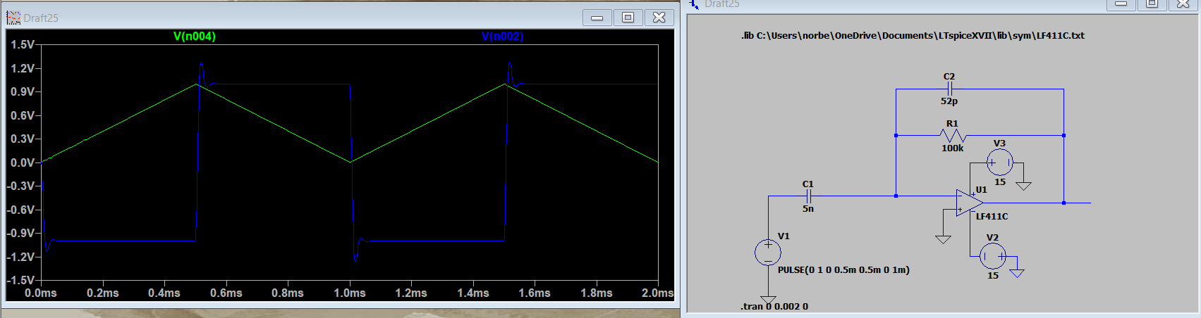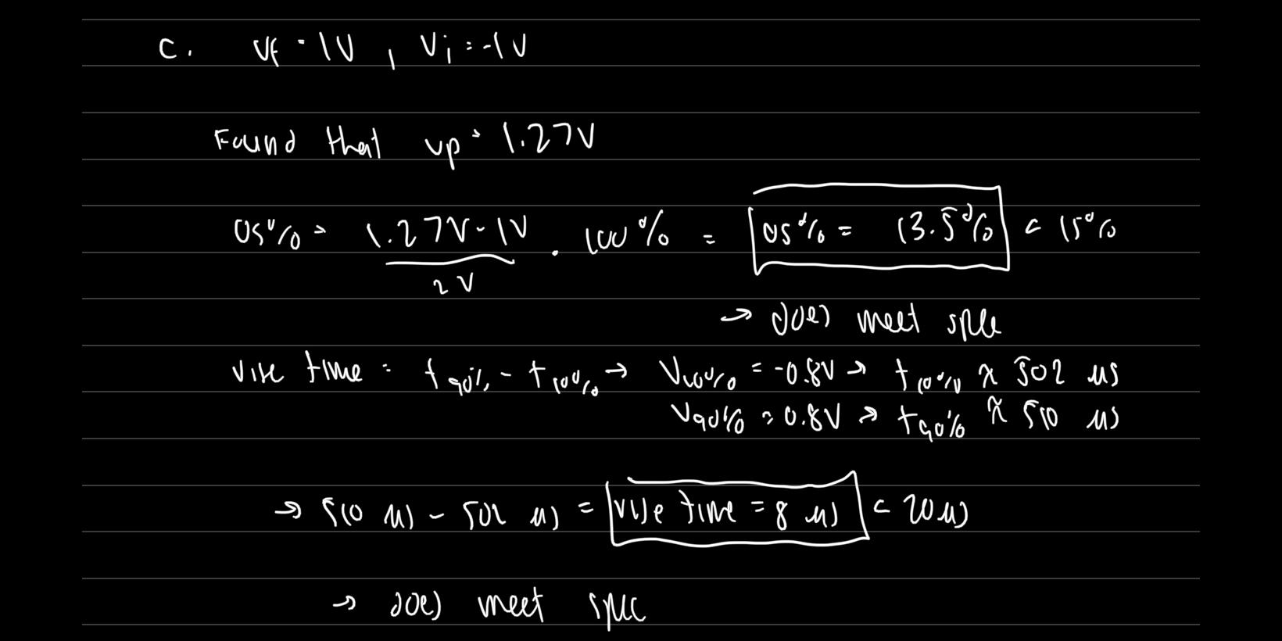

The figures above show the simulation results when we have a compensation capacitor in parallel with the resistor in Zf for the differentiator circuit. We measured that the overshoot percentage is about 13.5% and the rise time is about 8 microseconds. Comparing these results with the compensation capacitor with the compensation resistor, they both have the same rise time and overshoot percentage.

Problem 3: Measurement

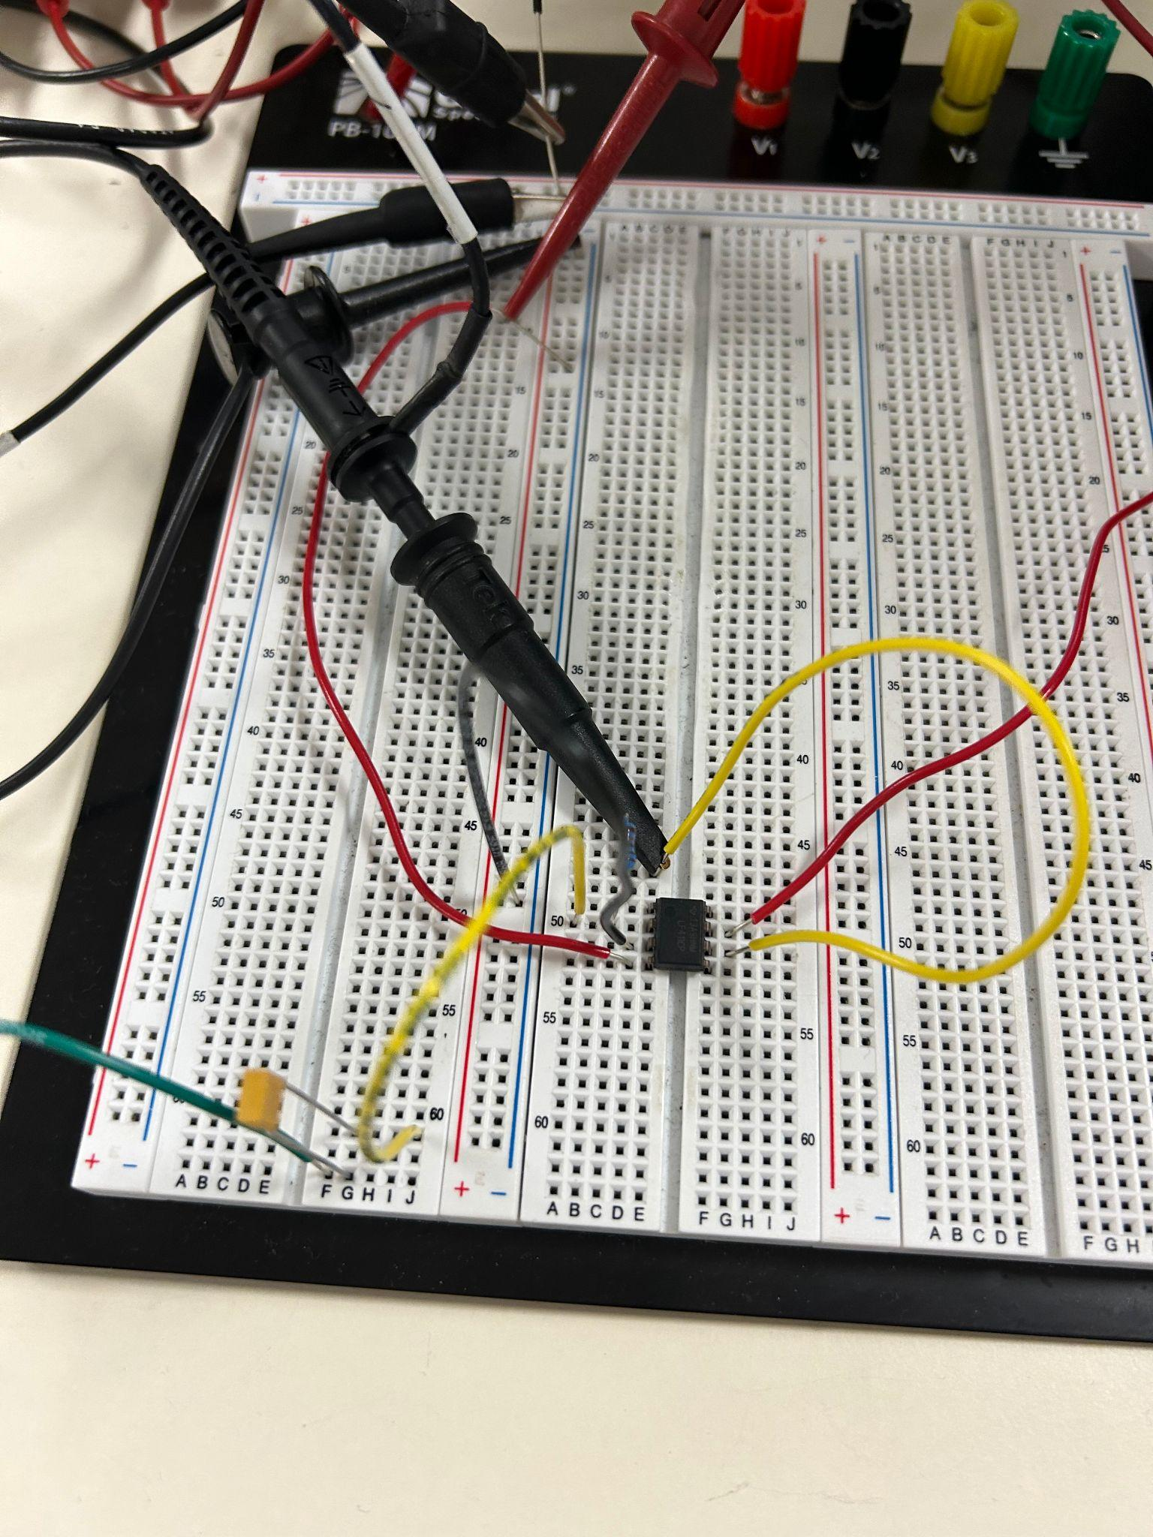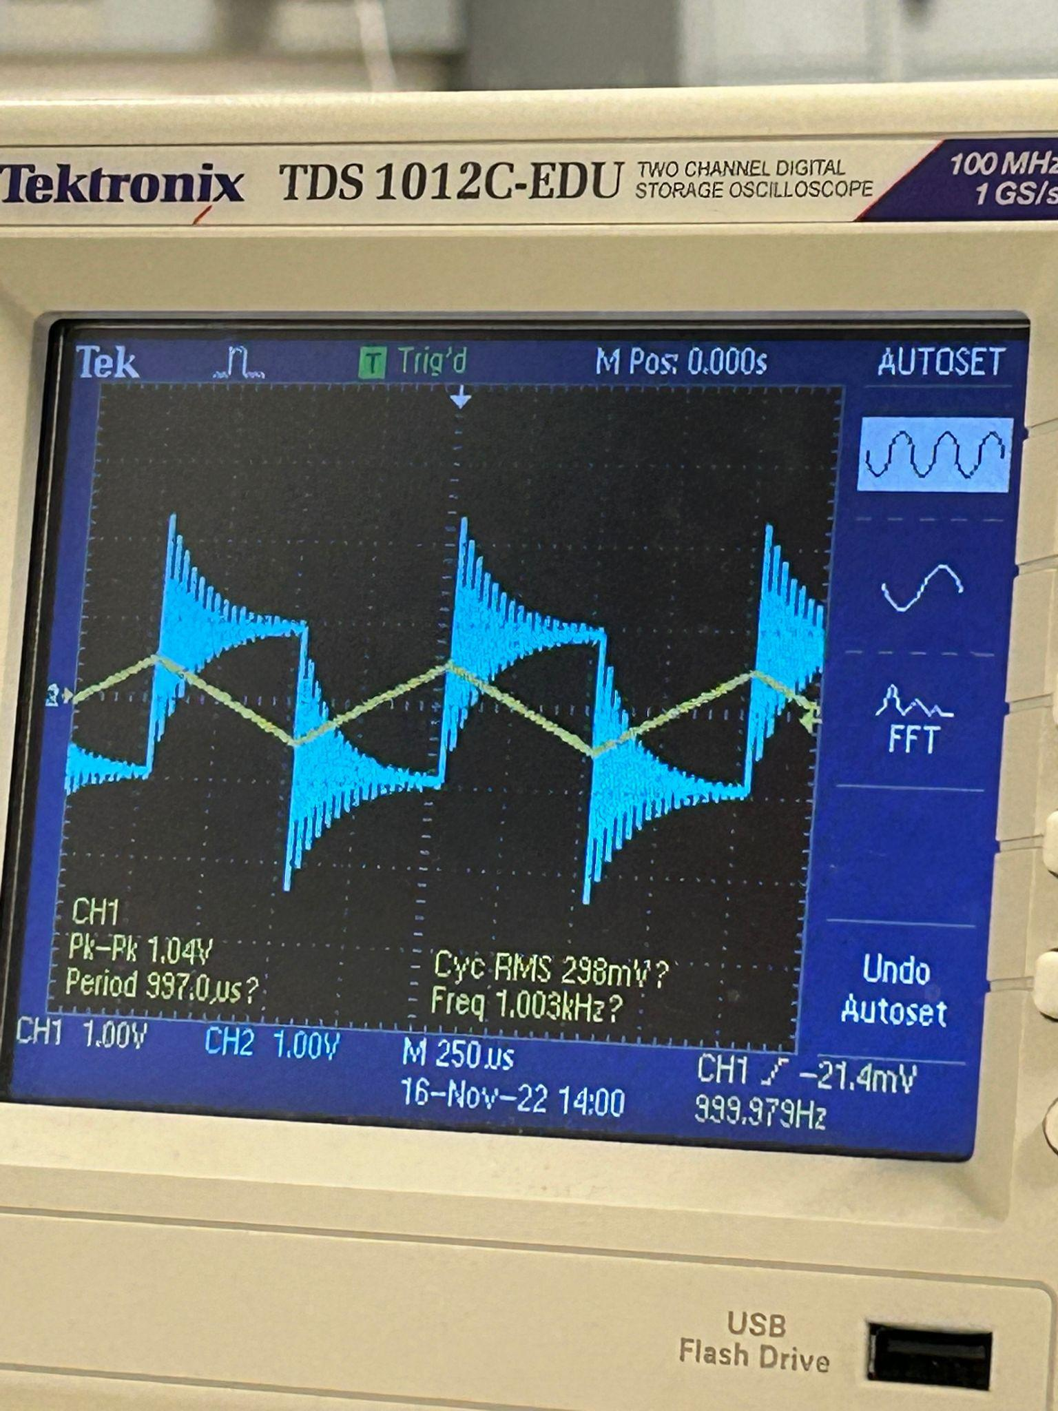

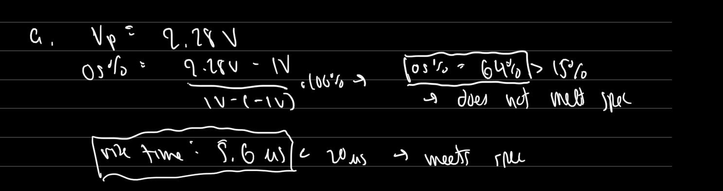

The figures above are the circuit and results for the differentiator circuit without compensation. We found that the overshoot percentage of this circuit is about 64% and the rise time is about 5.6 microseconds. Because the overshoot percentage is above the required maximum of the spec, this circuit does not meet the spec.

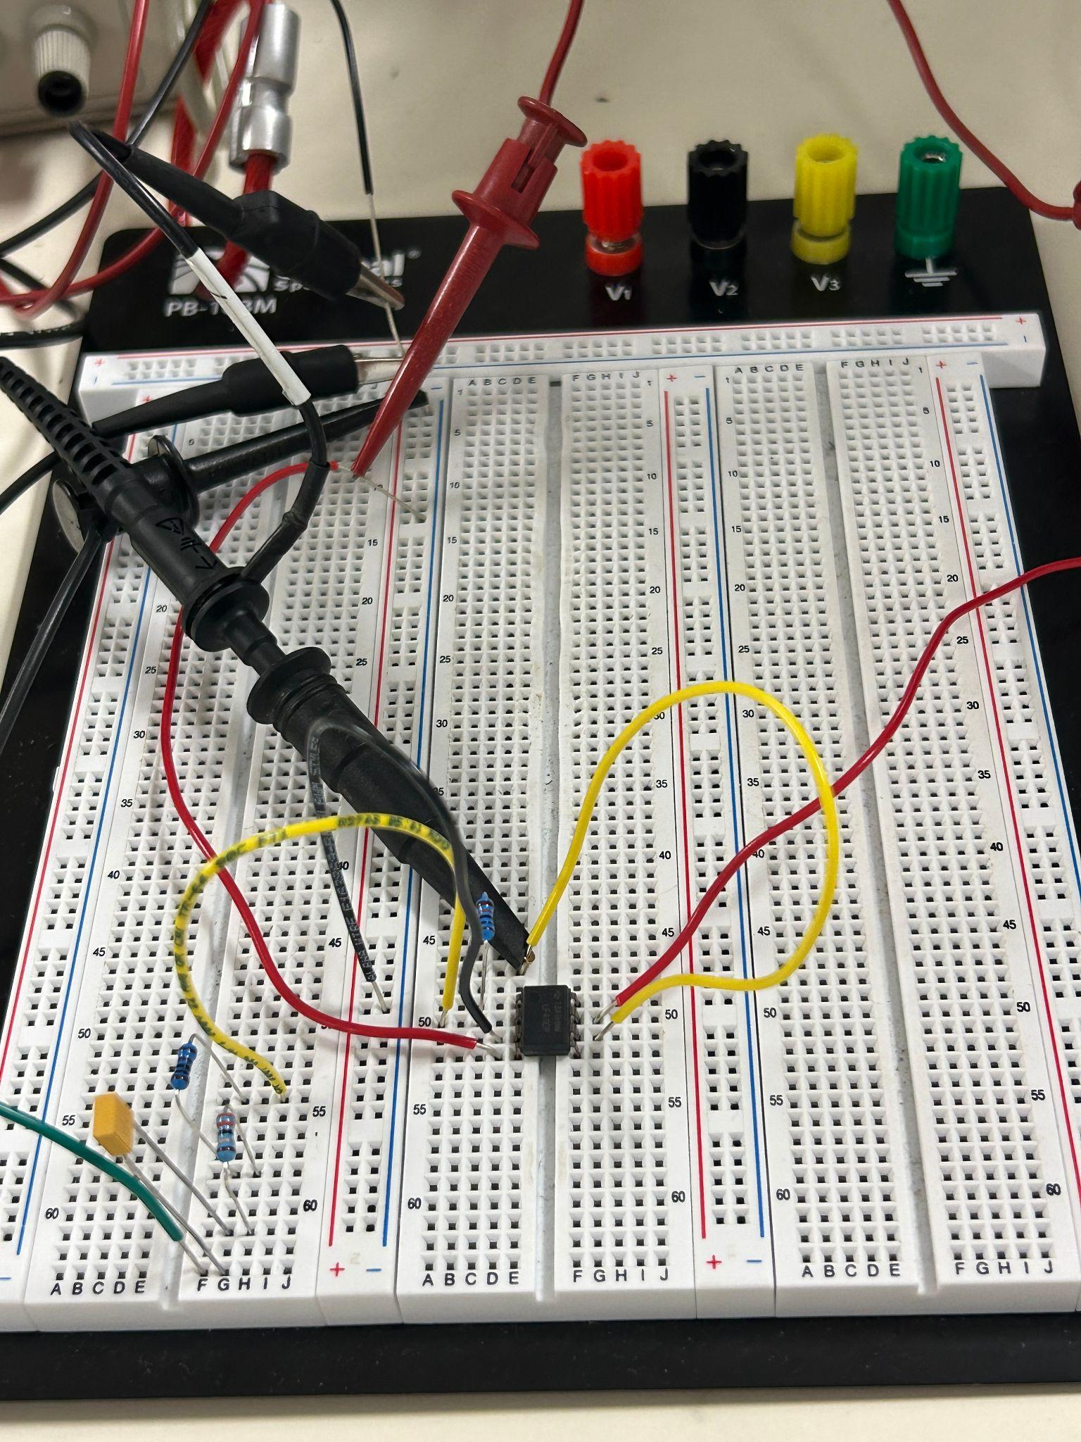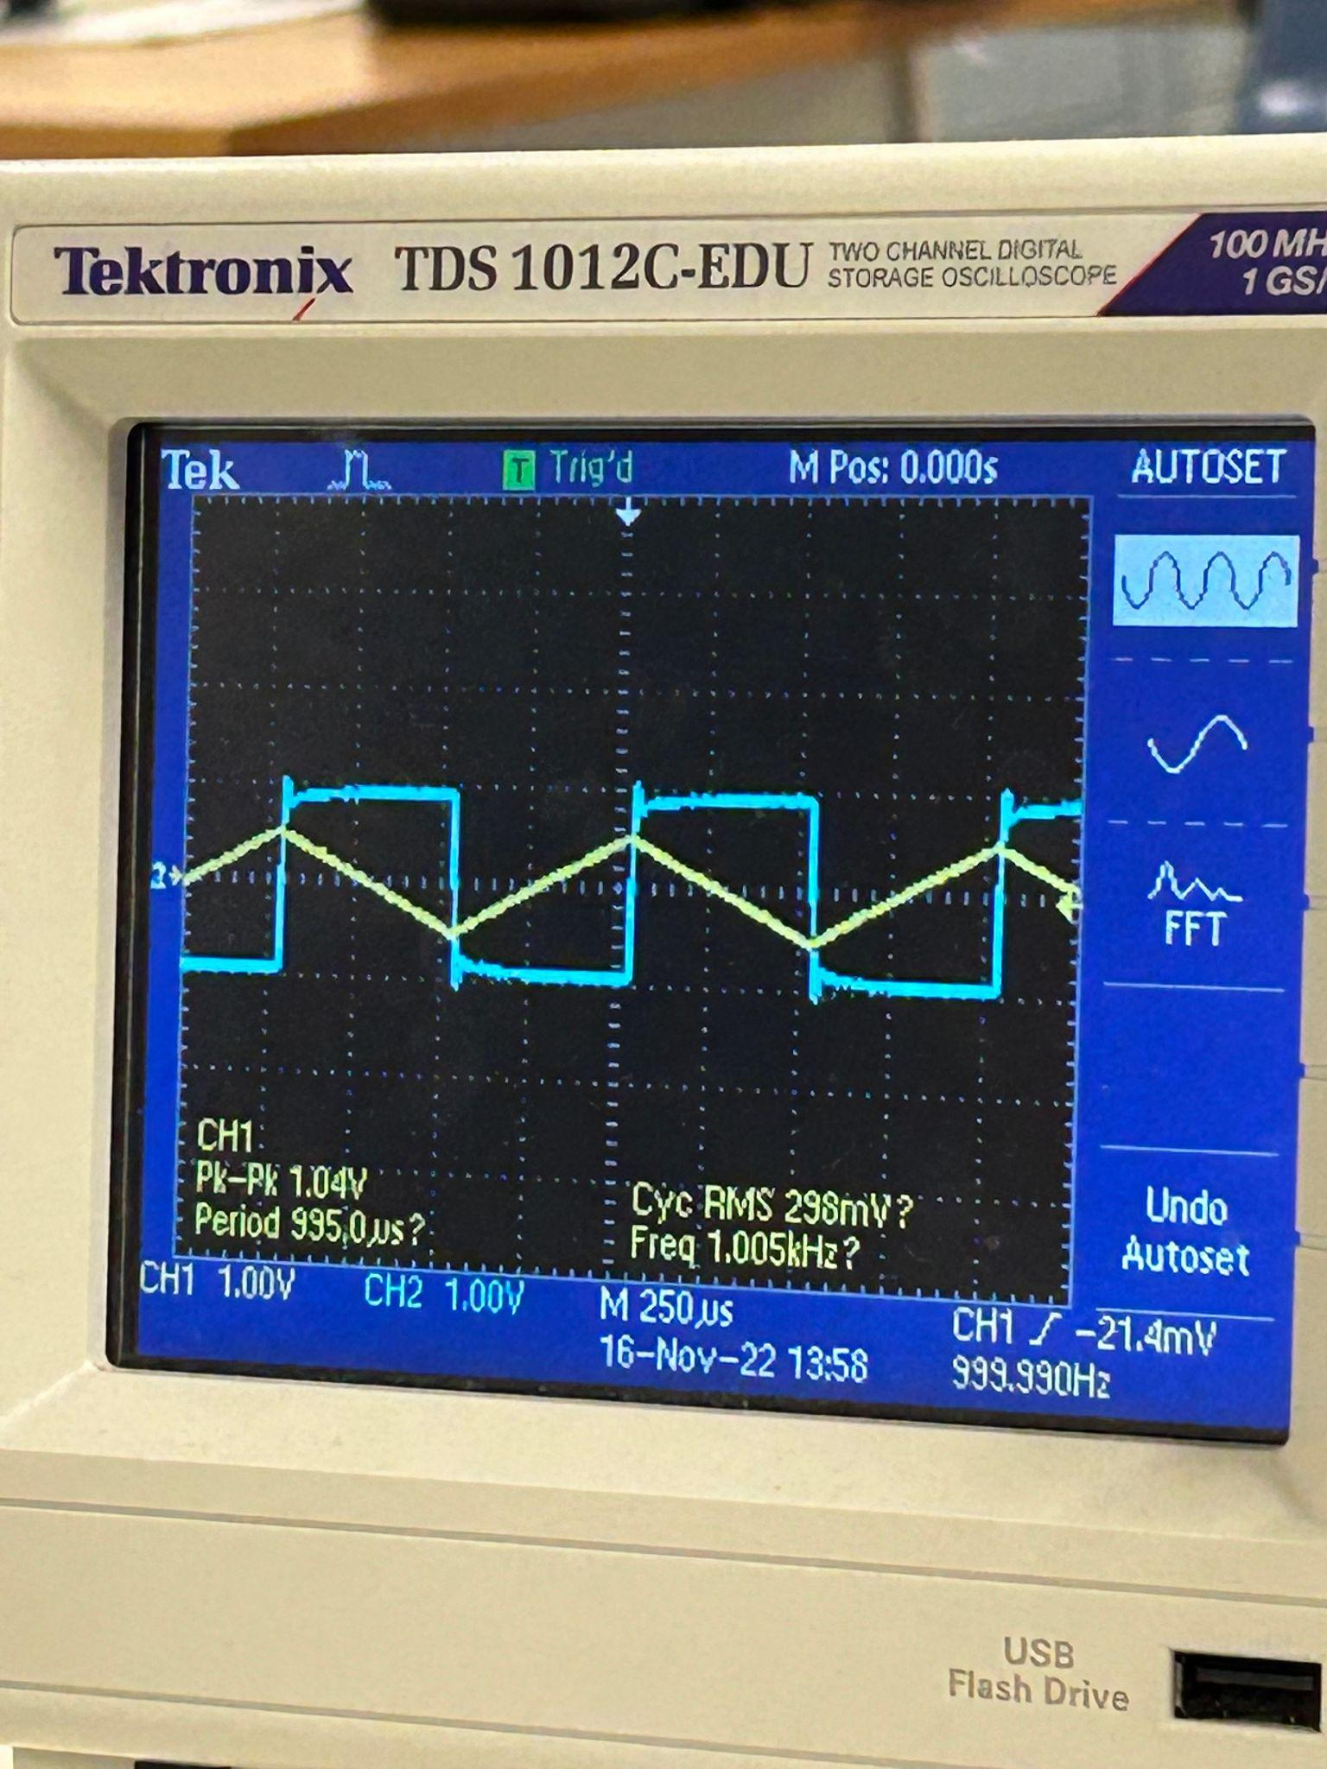

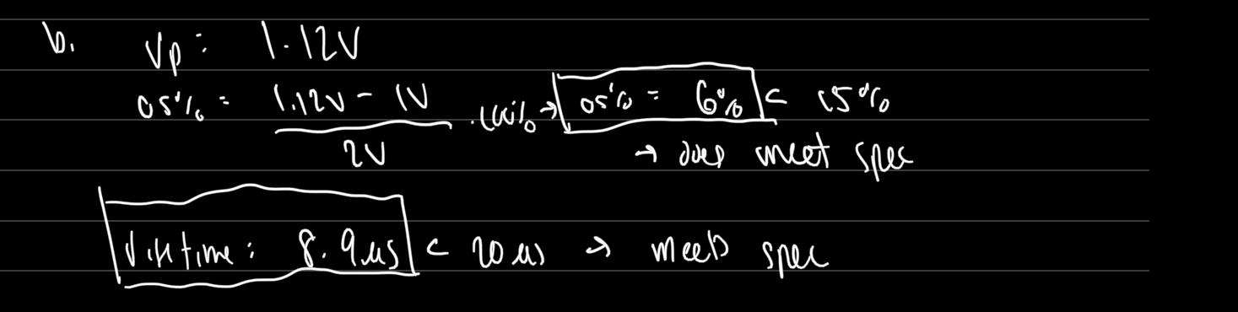

The figures above show the differentiator circuit when we add the compensation resistance of about 1030 Ohms. We found from the measurements that the overshoot percentage and the rise time does meet the spec with an overshoot percentage of about 6% and a rise time of about 8.9 microseconds.

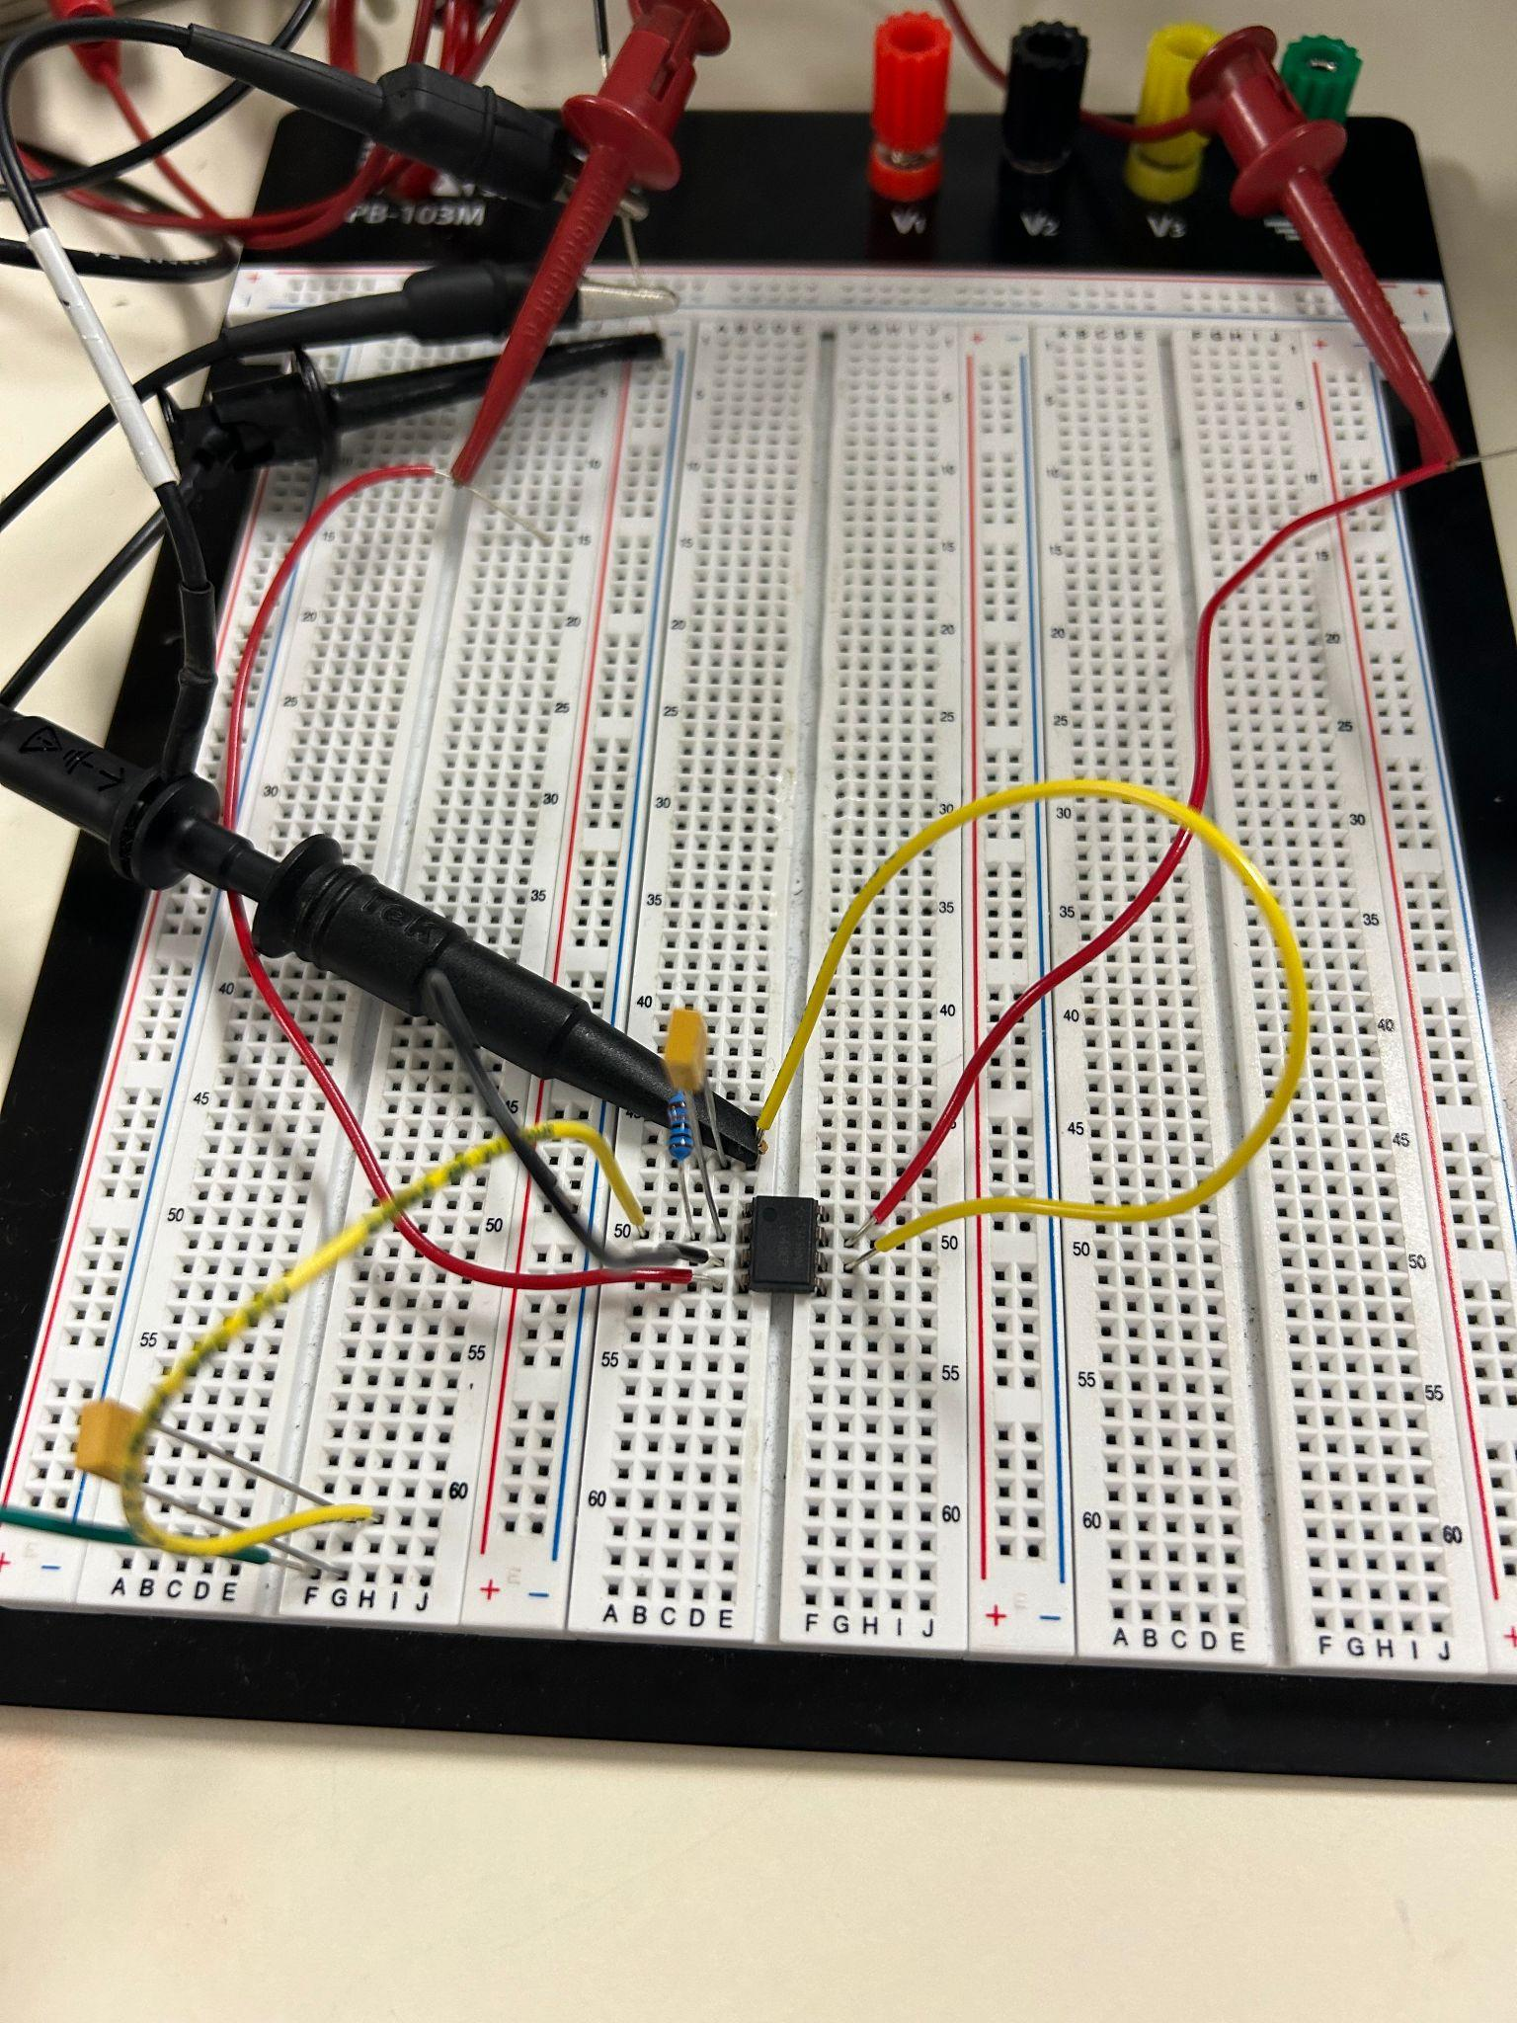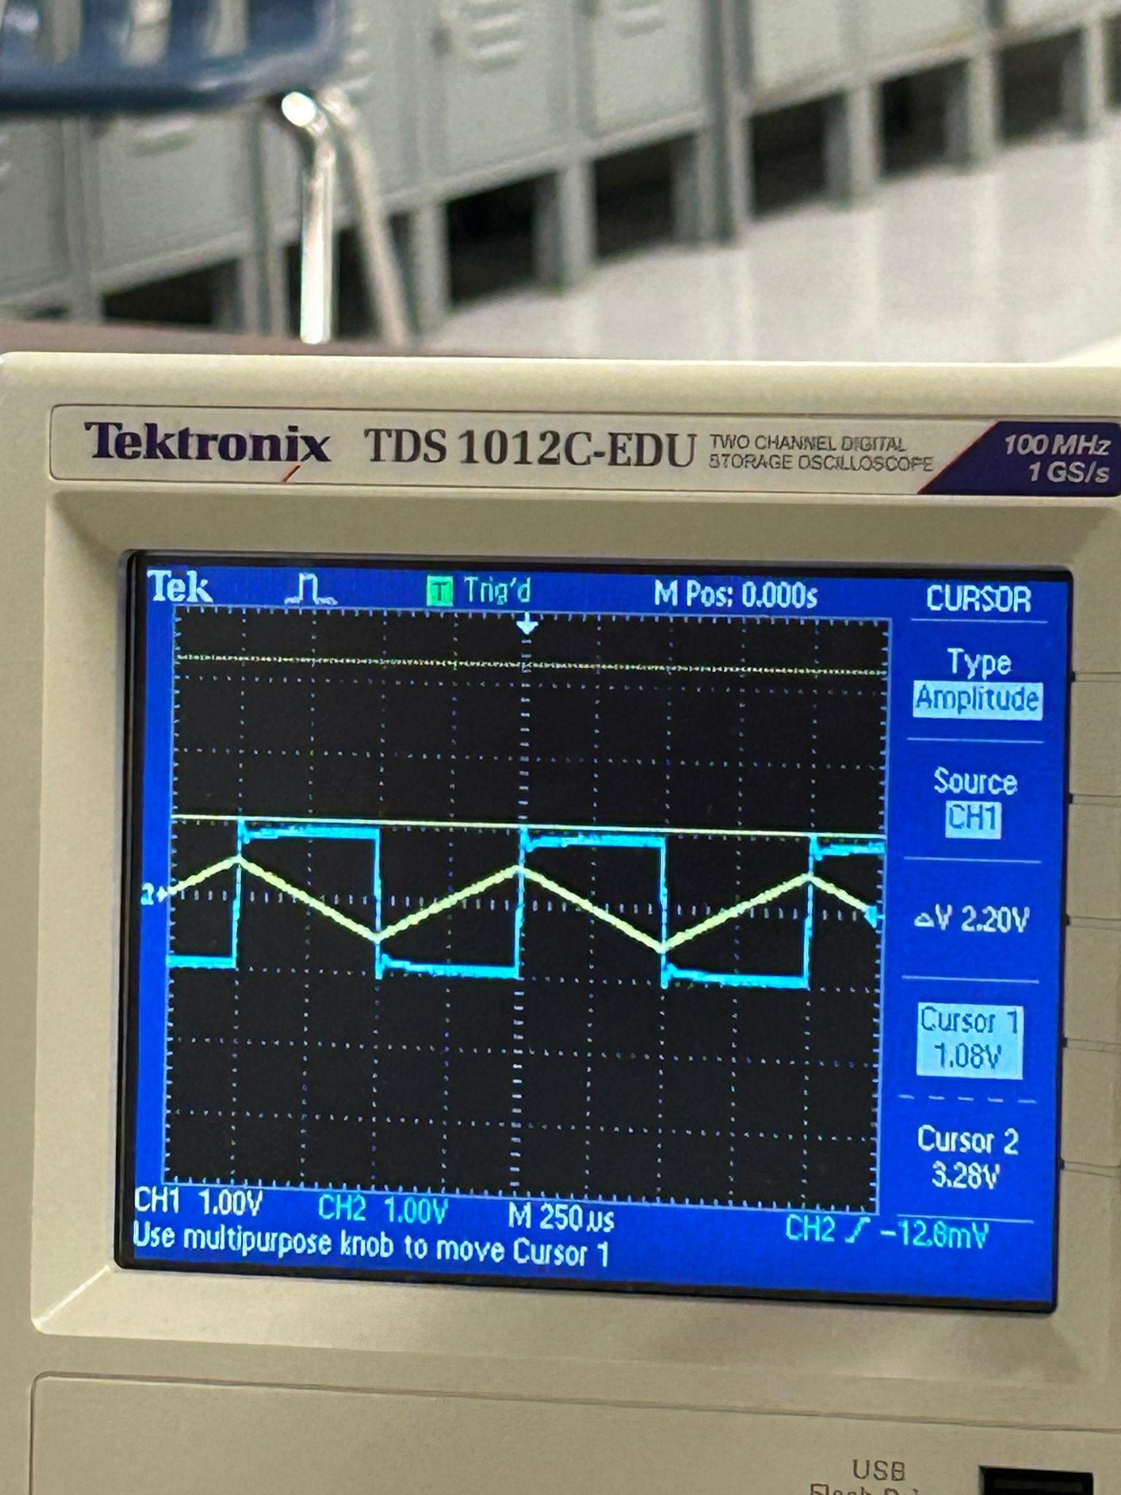

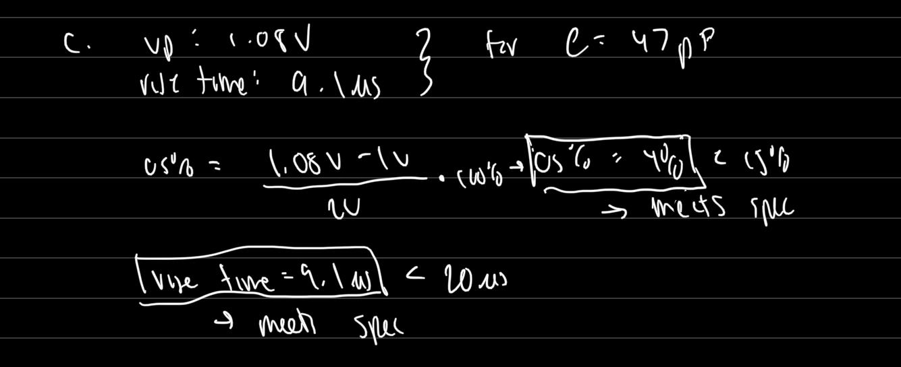

The figures above show the differentiator circuit with a compensation capacitor with a value of 47pF, which is close to our calculated value of 52pF. From using this value, we got the differentiator circuit to meet the spec with an overshoot percentage of 4% and a rise time of about 9.1 microseconds. Comparing these results to when we have a compensation resistor, they are the same, showing that adding a capacitor in parallel with the resistor has the same effect when we add a resistor in series with the capacitor of the circuit.

Conclusion

In the first part of the lab, we calculated values for our circuit that meets the spec. We calculated values for no compensation, a compensation resistor, and a compensation capacitor. We calculated the values for our resistor and capacitor to be 1030Ohms and 5nF by using the transfer function and general format and equating the zeta and omega naught. We also found that adding the compensation resistor and capacitor added another zero to the equation.

In the second part of the lab we were tasked with simulating the circuit with the values we calculated for the capacitor and resistors. Our graph did seem to match up as well as the compensation resistor and compensation capacitor. Our graphs in the simulations looked to match up with the expectations because without compensation the graphs oscillated and didn't turn into a square wave output. The circuit with the compensation did look like a square wave but would show some overshoot.

In the last part of the lab, we tested our simulation findings with the physical circuit. The reason we did this was to test if the real-world application would make a difference because it is not ideal like it is in the simulations. After testing our circuits we were able to find the results were similar to the simulations. Although we did have some differences between the compensation resistor and capacitor because our values weren’t the exact values, it still had consistent results because there was only a very small difference.